Mark's Pente Opening Book 2/7/2000

Opening Classification:

The opening is primarily classified by the first three moves. The first move is, of course, to the center, then the second move is designated by a letter A-H depending on its position in the diagram below. Then the third move is designated by a number in the diagram. 31=H, 32=E. (Many games will have to be rotated/flipped in order to match the diagram). Some openings may still not match, but that is unusual. Note: the classification is not assigned until the FOURTH move has been made, and then, if it simplifies the opening to switch the second and fourth moves, that is done -- I designated openings A and C as the "simplest" .

22 . . . 26 . . . 30
. 21 23 24 25 27 28 29 .
. 20 . . . . G H .
. 19 . . . C D E F
18 17 . . o A B 01 02
. 16 . . . . . 03 .
. 15 . . . . . 04 .
. 13 12 11 09 08 07 05 .
14 . . . 10 . . . 06

The r number is a reference number. The s number is a score from 1-9. 5 is neutral, 4 is slight advantage for white, 1 is sure win for white, 6 is slight advantage for black, 9 is sure win for black. Note: I have only used 4,5,6 so far! Some can be modified to more extremes. The number in parentheses is an illustrative game of that opening. Plain numbers are PBeM board numbers, a single letter preceding a number is a PBeM tournament game, cp games are from 1983 Championship, po from Pente Online, ai from computer analysis. The diagrams were made with Oleg Stepanov's Database program. To add to the document, enter the position in the program, hit F1. The file will be saved as pente.wmf. Now it can be inserted into the document as a picture. (I reduce it to 65%)

This opening book is far from complete -- do not be limited by it. There are more variations than there are openings here. Do not trust my scoring, maybe you can find a way for the other side to win. Also, if an opening position has a score of 6 - that does not mean that ALL of the moves in the diagram were good for black, maybe one of the white moves is a mistake and hence the good score for black.

A0

r16 s4 (2687)

A1
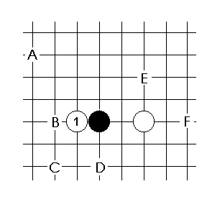
E see B1a, F see B1c

A1a

r80 s4 (3490)

A1b

r1 s5 (cp88)

A1c

r19 s4 (f38)

A1d

r44 s4 (2847)

r73 s4 (2000)

r2 s4 (2263)

A2

r66 s4

r47 s6
followed by....

r50 s4 (3552)

A5

r82 s5 (3427)

A6

r282 s6 (po9)

r284 s6 (po16)
then

r285 s5 (po43)

A7

r59 s4 (cp25)
If 4. L8, see C31

r72 s4
8=m6, 9=n8
see C31

A9
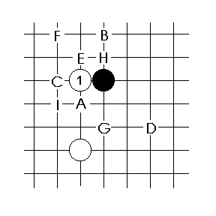
A see A1, G see C1a, H see C9f, I see C1k

A9b

r83 s4 (cp47)
o
r 7. K8 [r86] (2801)

r52 s4 (968, cp79)

r91 s4 (2698)

A9c

r114 s4 (2504, ai114)
followed by...

r277 s4 (h24)

r94 s4 (h14, 5222, po23)

A9d "Wallace opening"

r286 s4 (h54)

r89 s4
if 6. L8, then 7. M7 [r240](3106,f31)

r240 s4 (3106, f31)

r101 s4 (4976)

r4 s4 (4811, 4848)
identical to r101

r103 s4 (4497)

r5 s5 (cp66, 2632)

r111 s6 (4173, cp48)

r120 s5 (3193)

r122 s4 (3867)

A9f

r78 s4 (2199, d23)

r67 s4 (2748)

A10
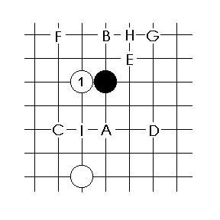

A10a

r131 s5 (4182, 4078)
8=j11, 9=n8

r9 s4 (3007)

r88 s6 (3204, a53)

r10 s5 (2531, 3827, ms3)
black can try 10. L12, L11, M12

r138 s6 (1659)

r287 s4 (h73)

A10b

r8 s4 (2119)

A10c

r133 s4 (1957, c24)

r134 s4 (3890)

r135 s4 (f28)
or 7. M11 [r258](g25)

A10d

r288 s5 (po24)

r139 s5

r257 s4 (4994)

r259 s6 (f81, 5110)

r278 s4 (5105)

s289 s4 (h34)

r68 s6 (2707)

r260 s6 (g56)

r140 s5 (2200)

r141 s6 (cp28, f71)

r84 s6 (2873)

A10e

r109 s5 (3153)

A10f

r90 s6 (3205)

r6 s4 (2414)

r7 s4 (2423, 2118)

A10g

r124 s4 (4717)

A10h

r136 s4 (3871)

A10i

r137 s4 (d43)

A13

r12 s4
or without 10,11 = r142 (1568)

r143 s5

A17

r145 s5
8=k9 followed by....

r261 s4 (g62)

r146 s6 (4760)

r147 s5 (pod 15)
A18

r148 s6 (sp82-2)

r13 s5 (cp12)

r79 s5 (cp15)

r14 s5 (2949)
B1 "Potential opening"
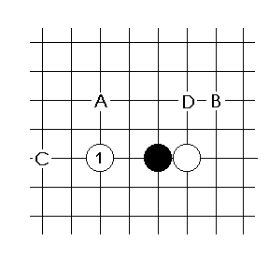
D see A1d

B1a

r149 s5 (4998)

r22 s4

r17 s6 (2908)

r23 s4

r11 s6

r150 s4
10=n12, 11=m12

r18 s6 (2485)

r85 s4 (4737)
followed by…

r151 s4 (3731)

B1b

r152 s4 (2459)

B1c

r28 s5 (1348)

r153 s5

B2

r154 s4 (1926)

r21 s4 (cp35)

r155 s4 (2129)

r20 s6 (cp85)

B3

r156 s4 (512)

B4

r157 s4

B5

r158 s6

B9 -- see B1a

r262 s5 (4952)

B10

r159 s5

r24 s4 (cp17)

r25 s4 (1059)

r26 s4 (2718)

r160 s5 (2068)

B17

r27 s4 (2015)

r161 s4 (2935)

B18

r162 s5

C1
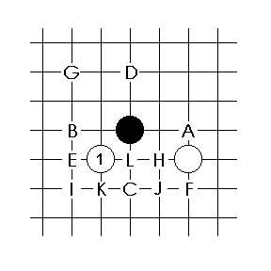

C1a
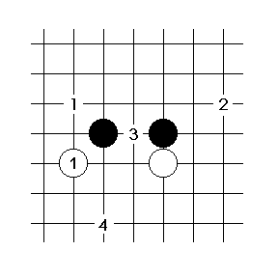
(C1a5)
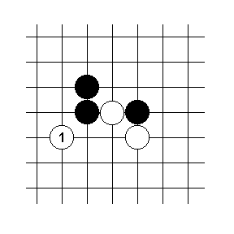

C1a1 "Hammer"

r34 s6 (cp73, cp20)
if 9. m12 [r166](2906) or n12 [r167](3018) play the same 10 and 12.

r168 s4 (2707)

C1a2

r35 s5 (cp26, 2934)

C1a3 (variant of the wedge)

r40 s4 (a24, d16)

r125 s4 (1140, 4688)
If 10. K9 then 11. M9 [r175](a23,e13)
If 10. L10 then 11. L8 [r176](3714)

r42 s4 (a24, cp49)

C1a5 "The Wedge"
...commonly continues with exchange of captures...

r36 s4 (3709,3707)
Or 15. N11 [r37] (e16)

r172 s4 (cp130,cp111)
Or 15. O14. [r173](cp119, 4183)

r174 s4 (sp84-8, f18)

r171 s4 (4403)
A different 12, still followed by 13. O12

r39 s4 (cp72)
A different 10.

r38 s4 (cp65)
A different 9. Also 13. L13 [r170](2153)

r169 s4 (cp128, 3649)
A different 8, but still followed by 9. L13.

C1b

r123 s4 (2729)

r32 s5 (cp27)

r164 s4 (3640)

r33 s5 (3320)

r165 s4 (4549)

C1c "Cross opening"

r45 s4 (4698, 4686)
followed by...

r187 s4 (1633)

r188 s4 (3139, 5025)
9. captures at N11

r189 s5 (b21)

r190 s5
11. captures at K8 followed by 12. M10

r295 s4 (5192)

r116 s4 (3391)

r191 s4 (4616)

r46 s4 (cp21, b23)

r192 s6 (3115)

C1d

r31 s4 (4495, cp11)

r296 s4 (5120)

r263 s5 (4617)

C1e “Boston opening”
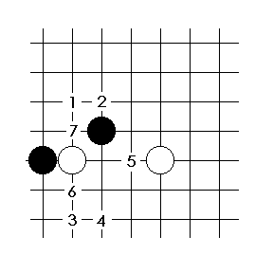
C1e1

r43 s5 (cp113)

r92 s6 (3549)

C1e2

r118 s5 (3457, 5117, h76)

r177 s6 (3633)

r178 s5 (3492, 4685, 3615, h72)

C1e3

r254 s6 (5007, 5019)

r297 s5 (h31, h13)

r110 s6 (3634, 4633, 4990)

r183 s6 (4338)

r117 s4 (3311)

r99 s6 (3553)
10 is K12.

r184 s4 (4615)

r185 s4 (4569, f13)

r266 s4 (5056)

r264 s6 (5054)

r265 s5 (g61, g21, h45, ai265)
12. is K9

r41 s4 (g54, f38)

r255 s4 (5023, 5059, h43)
or 9. M10 [r15](h26)

r256 s4 (ai256)

C1e4

r98 s5 (3529)

C1e5

r179 s4 (3805)

r180 s5 (4494)
Followed by the exchange 8. O10, 9. L12

r268 s5 (g14)
with the captures 8. O10, 9. L9. = r180

r181 s5 (3519)
After 8. L10, 9. L9 is identical to r180

r182 s6 (4685, 4635, 5115)

C1e6

r280 s4 (4847, h47)
then:

r298 s4 (5148)

C1e7

r299 s5 (5111)
after capturing:
or 9. H11 [r300](5088)

C1f

r193 s4 (2717, 4578)

C1g “Colbert’s variation”

r163 s4 (cp31, cp101)

r29 s5 (cp50)

r30 s5 (cp53)

C1h

r186 s4 (g57, b26)

C1i

r56 s4 (3736, 4796)

C1j

r291 s4 (h36)

r292 s4 (h53)

C1k

r301 s4 (5149)

r302 s4 (5167)

C1l

r293 s4 (5080)
Or 7. M11 [r294](5067)

C2
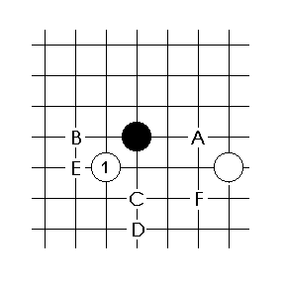
C2a

r208 s6 (3284)

r209 s6 (3679)

r210 s4
Next are the two captures K8 and J11.

r105 s4 (3217)

r211 s5

C2b

r194 s5 (4810, 5266)

r269 s6 (g41)

r304 s5

r195 s6 (3840)
and then...

r196 s5 (3973)

r197 s4 (4516)
9. Q10 (po42)

r279 s6 (5113)

r303 s6 (po56)

r198 s5 (4944, po11)

r305 s4 (5168)

r199 s6 (4406, 4746)

r48 s6 (4555, 3934)
May also insert 9. p10, 10. q10 [r200](f83)

r202 s6
May also insert 9. p10, 10. q10 [r201](4736)

r203 s5 (a42)

r204 s6 (4561)

r205 s4 (2011)

r81 s6 (3756)

r206 s5 (c41)

r207 s6 (4513, 5051)

C2c
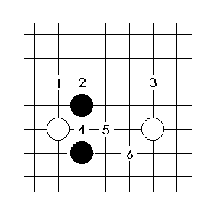
C2c1

r113 s4 (3306, 3564)
C2c2 “Krenz attack”

r130 s6 (4808)

r95 s6 (cp96, e61)

C2c3

r70 s4 (3309)

r100 s4 (3218)

r115 s4 (3322)

r106 s4 (3418, 4378)

r65 s4 (3868, f57)

r104 s4 (f35)
C2c4

r127 s4 (3206)

r49 s5 (3274, 3637, 4643)
and then...
or 10. J12 [r102](3123, 3294)

C2c5

r51 s6 (b82, 4725)

r87 s4 (3181)

C2c6

r126 s5 (2942)

C2d

r121 s5 (3643)
followed with

C2e

r212 s4 (3824)

r213 s6 (3431)

C2f

r214 s4 (4934)

r69 s4 (1569)

C4
If 4. J11 see C12

r270 s4 (4975)

C5

r215 s5 (1283)

r216 s5 (303)

C6

r307 s5 (5211)

r217 s5 (d34)

C7

r306 s6 (po28)

C8

r128 s5 (2473)

r129 s5 (2719)

C9
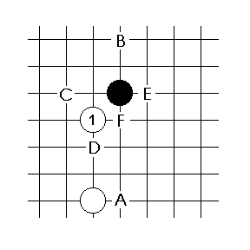
C9a

r61 s6 (e31)
9. L12, 10. M6

r230 s4 (3571)

C9b

r308 s5 (ai308)

r218 s4 (c12, 5109)

r71 s5 (cp56, cp21)

C9c

r219 s6 (g71, 3639)

r119 s5 (1848, 3547)

r220 s6 (4647)
8. K12 then....

r221 s4 (3735, f36)

r222 s6 (4924)

r309 s5 (5097, h32)

r223 s4 (4541,f25)
then

r53 s6 (593, 4338)

r310 s5 (5125)

r224 s6 (1578)

r55 s6 (1613, 2532)

r271 s6 (g71, 5093)

r54 s5 (3612)

r225 s4 (3238)

r226 s5 (4442, 5062)

C9d

r229 s4 (4511)

C9e

then
r312 s5 (h62)
or
r227 s5 (h65)

or
r313 s5 (4991)
or
r314 s5 (po57)

r272 s6 (g75)

r311 s5 (ai311)
10. J10, 11. N10

r228 s5 (5020, 5062)

C9f

r316 s4 (h41)
exchanging 8. K11, 9. L9

r315 s5 (h21)
exchanging 7. L12, 8. J11

C10
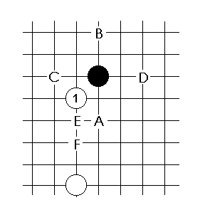
A - see C2

C10b

r231 s6 (4996, 4550)

r57 s5 (cp39)

r232 s5 (3068, d32)

r233 s4 (f23)

r317 s5 (5213)

r234 s6 (f76)

C10c

r235 s6 (3858)
then
like C9 r220

r236 s6 (4570)

r237 s6 (e72)

r132 s6 (f85)

r97 s5 (3489)

r58 s5 (671)

r107 s5 (3136, 4609)

r108 s6 (b74, 2822)

r112 s5 (3378)

r238 s6 (c42)

r239 s4 (2011)

C10d

r96 s4 (3290)

C10e

r273 s6 (g65)

r3 s4 (b25, cp51)
then

r241 s6 (484)

C10f

r242 s5 (cp122, cp123)

r243 s4 (b76)

r244 s5 (e37)

C12

r60 s6 (5119)

C27

r93 s6 (3730)

C31 “Cooper’s opening”

r245 s6
=r34 C1a1 "Hammer"

r62 s4 (cp121)
then

r63 s5 (cp54, 2576)
followed by...

r318 s4 (po47)

r319 s5 (5223)
8. captures at M10 then 9. either J9 or N9

r274 s6 (4447)

C32

r321 s5 (4951)

r246 s6 (3730)

r320 s4 (4936)

r64 c6 (2466)

D1 see C1

D17

r322 s5 (5193)

D31

r247 s4 (214)

E1 See A9.
E2 See C2.

E27

r248 s6

E31
see C31

F1 See C9.
F2 See A10.

F9

r323 s5 (po21)

F17 “Dallas”

r249 s4 (cp84)

r324 s5 (po46)
then

r250 s6 (h61, h63)

F18

r251 s6 (f64)

r252 s4 (f24)

F26

r74 s6 (cp87)

G1
see A1d

r326 s4 (ai326)

G2
4. M10 = B2; 4. K12 = B10

G9
4. M10 = B9; 4. K12 = B17

G10

r75 s4 (cp13)

H1 “Allen’s opening”

r76 s5

r77 s4 (cp43)

r253 s6 (4738)

H2
4. L10 or N10 = A2

H10

r276 s4 (g26)

H17
See A17

H25

r275 s4 (g12)

see A9d
{end}

